9.73: a) 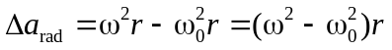
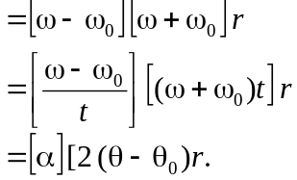
b) From the above,
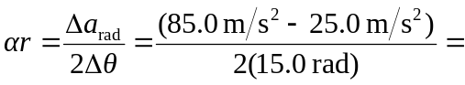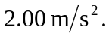
c) Similar to the derivation of part (a),
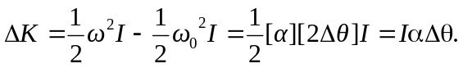
d) Using the result of part (c),
